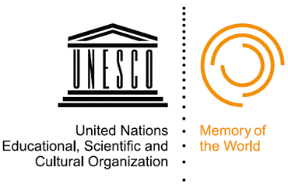 | UNESCO PERSIST Programme & Foundation  How can we make our digital heritage last?

What is the problem?
We constantly create and use digital content. Our access to it is dependent on software which continuously evolves. As new software is created, older versions become outdated and no longer work.
Consequence: We can no longer access the content.
What do we do about this?
We deal with the problem by constantly “converting” our old files into new formats so that we can use them with new software. For example, we may save an old Word file in a more recent format. That is called “migration”.
Is migration a sustainable solution?
No, migration alone is not a solution for a number of reasons:
- It is increasingly expensive for Memory Institutions (libraries, archives, museums, etc.) to migrate ever growing amounts of content constantly from one format to the next.
- We inevitably lose some aspects of the content. New formats and new software do not have the same properties as the old ones. For example, having a PDF version of a budget spreadsheet is much less useful than a spreadsheet with calculations.
- We lose ALL the information. New software versions can often read previous versions of files. However, the software producers cannot ensure that forever. At some point they need to introduce new products and discontinue the old ones. At that moment all the files in the previous format become inaccessible and lost to us. We lose our past.
- We lose cultural heritage. Migrating digital heritage content may significantly alter our ability to learn about our past. For example, we may wish to study how people used the Web site of the Olympic Games held in Atlanta in 1996. If we use a modern version of Microsoft Internet Explorer, we will hardly be able to understand what it meant to use the Internet and to experience the Games online in 1992.
So what else can we do?
Instead of constantly migrating old files into new versions, we can leave the old files as they are and preserve the old software to read them. We can then still read and use the original file with original software.
Example. Below are fully operational desktops that we used in the past: Microsoft: Windows’95 (now 22 years old), Windows’98 (19 years old) and Windows XP (2003) (14 years old). By preserving them we can ensure access to all the old files we created with this old software.
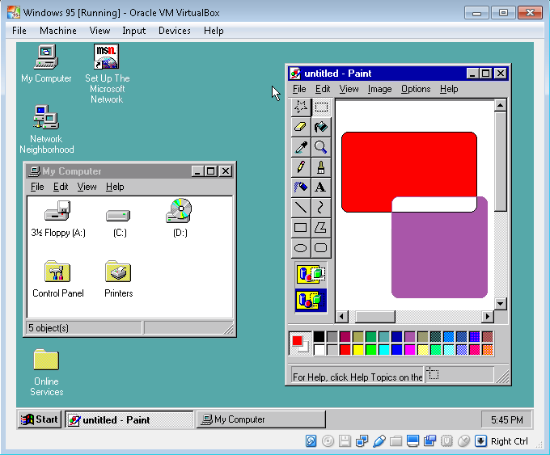  Microsoft Win’95 Operating System. Showing the MS Windows Explorer and the Paint application. | 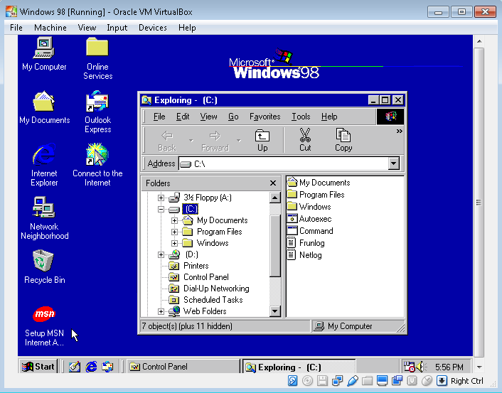  Microsoft Win’98 Operating System. Showing the MS Windows Explorer. | 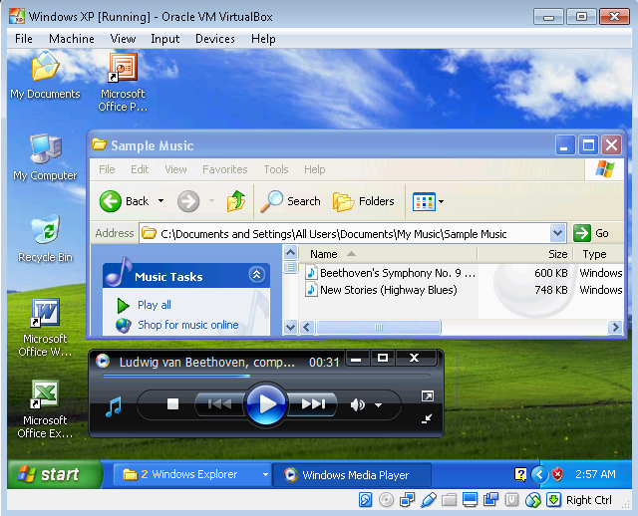  Microsoft XP Operating System. Playing music using the MS Media Player.

This seems simple: Why don’t we do this already?
As computers evolve, we can no longer use old software on modern computers with modern operating systems. However, there is a technical solution. Computer experts are providing technologies that make a modern computer “function like an old one”. For example we can still listen to a digital music recording from the 90s in the old XP desktop because the old software for listening music is “understood” by the new computer and can make the music file play by the old software.
The UNESCO PERSIST Programme can help!
First, as the “digital part” of the UNESCO’s Memory of the World (MoW) Programme, the UNESCO PERSIST Programme will engage with the ICT industry for the right to use old software. Second, the Programme will set up the PERSIST Foundation to run old software on modern computers. In this way, Memory Institutions and their partners will be able to continue to use old software to access old digital files.
Who pays?
It is expected that many users (Memory Institutions, companies, governments, etc.) will need to access old content and will be prepared to pay for using old software. The PERSIST Foundation will pool expertise from technical communities to create efficient and cost effective “old software services”. These services will generate sufficient revenue to be financially sustainable.
What is UNESCO’s added value?
Firstly, as the UN platform for cultural heritage, communication and information, UNESCO has the credibility and neutrality to convene the world’s decision-makers and experts to address the problem of old software and prevent digital amnesia. Secondly, as an intergovernmental organization, UNESCO has the mandate to develop standards and facilitate their adoption by the governments of its 195 Member States. For that reason, companies are keen to be involved in the development of these global policies and standards since these will influence their business.
Why would governments support and invest in the PERSIST Foundation?
Old software is necessary for accessing digital heritage as well as ever growing amounts of content and data in science, education and research. For that reason the UNESCO Member States have already committed to the UNESCO Recommendation (November 2015) regarding the preservation of documentary heritage, including digital heritage. The PERSIST Foundation will help them implement this Recommendation.
What is the relationship between the PERSIST Programme and the PERSIST Foundation?
The PERSIST Foundation is just one tool of the PERSIST Programme to facilitate the preservation of digital heritage. The mission and the activities of the PERSIST Programme reach beyond the work of the Foundation. It aims to secure the future of digital content by promoting collaboration among key stakeholders, including:
- Memory and Cultural Institutions (software users)
- ICT community (software providers)
- Governments (facilitators).
What are the core PERSIST Programme activities?
PERSIST helps UNESCO Member States to develop policies for preserving digital heritage. In addition, PERSIST is involved in the dissemination of best practices that enable Member States to implement these policies. A broad impact can be achieved, for example, through the PERSIST’s Content Selection Guidelines (http://unesdoc.unesco.org/images/0024/002442/244280E.pdf). These guidelines advise memory and cultural institutions how to select valuable content from a growing amount of digital information (think of social media!). Finally, PERSIST fosters technological solutions to reduce the impact of ageing software on access to digital information.

 | 
Mr. Stein van Oosteren  UNESCO PERSIST Programme Coordinator  Attaché at the Permanent Delegation of the Kingdom of the Netherlands to UNESCO. | Ms. Natasa Milic-Frayling  UNESCO PERSIST Programme, Chair of Technology and Research Workgroup  Professor, Chair in Data Science, University of Nottingham, UK.
UNESCO PERSIST Programme https://unescopersist.org Twitter Hashtag: #UnescoPERSIST
Video: https://www.youtube.com/watch?v=L36EbzPnzoM

